

Project Charter©
For [Project Name]

Document Control

Document Information
© | Information
Document Id | [Document Management System #]
Document Owner | [Owner Name]
Issue Date | [Date]
Last Saved Date | [Date]
File Name | [Name]

Document History
Version | Issue Date | Changes
[1.0] | [Date] | [Section, Page(s) and Text Revised]

Document Approvals
Role | Name | Signature© | Date
Project Sponsor

Project Review Group

Project Manager©

Quality Manager
(if applicable)

Procurement Manager
(if applicable)

Communications Manager
(if applicable)

Project Office Manager
(if applicable)

Table of Contents

Template Guide 1
1 Executive Summary 2
2 Project Definition 2
2.1 Vision 2
2.2 Objectives 2
2.3 Scope 3
2.4 Deliverables 3
3 Project Organisation 4
3.1 Customers 4
3.2 Stakeholders 4
3.3 Roles 5
3.4 Responsibilities 5
3.5 Structure 7
4 Project Plan 8
4.1 Approach 8
4.2 Overall Plan 8
4.3 Resource Plan 9
4.4 Financial Plan 10
4.5 Quality Plan 10
5 Project Considerations 11
5.1 Risks 11
5.2 Issues 11
5.3 Assumptions 12
5.4 Constraints 12
6 Appendix 12
6.1 Supporting Documentation 12

Template Guide

What is a Project Charter?

A Project Charter is a document which outlines the purpose of the project, the way the project will be structured and how it will be successfully implemented. It describes the project:

- Vision, objectives, scope and deliverables (i.e. what we have to achieve)
- Stakeholders, roles and responsibilities (i.e. who will take part in it)
- Resource, financial and quality plans (i.e. how it will be undertaken). ©

The Project Charter may also be referred to as a “Terms of Reference (TOR)” or “Project Definition Report (PDR)”.

When do I use a Project Charter?

The Project Charter is usually presented by Senior Management within the business to an identified Business Sponsor. It is completed after the Business Case and Feasibility Study have been approved but before the Project Team is formally appointed.

Furthermore:

- The Project Charter defines the boundaries for the project. It describes in detail the scope of the project, within which all deliverables must be produced. Activities should be undertaken outside the defined scope of the project only if a valid ‘change request form’ has been approved by the Project Sponsor
- The next stage following approval of the Project Charter is the formal appointment of the project team. ©

How to use this template
This document provides a guide on the topics usually included in a Project Charter. Sections may be added, removed or redefined at your leisure to meet your particular business circumstance. Example tables, diagrams and charts have been added (where suitable) to provide further guidance on how to complete each relevant section.

Executive Summary

Sum up each of the sections in this document concisely by outlining the project:

- Definition
- Organisation and plan
- Risks and issues
- Assumptions and constraints. ©

Project Definition

This section describes what the project sets out to achieve. It outlines the vision for the project, the key objectives to be met, the scope of work to be undertaken and the deliverables to be produced.

Vision
Describe the overall vision of the project. The vision statement should be short, concise and achievable. Examples of vision statements include:

- To deliver a robust, scalable financial management system to the business
- To procure new work premises with adequate capacity and functional surrounds
- To successfully introduce new customer service processes to the marketplace. ©

Objectives
List the key objectives of the project. Objectives are statements which describe in more detail what it is that the project is going to achieve. All objectives listed should be Specific, Measurable, Achievable, Realistic and Time-bound (SMART).

Business Objectives
List the business-specific objectives to be achieved. For example:

- To deliver new accounts payable and receivable and payroll processes, thereby reducing financial processing timescales by at least 30%
- To build brand new work premises with 50% more space, 30 more cark parks and 20% fewer operational costs than the existing premises
- To provide a new customer complaints service to enable customers to issue complaints on-line and receive a direct response from the company within 24hrs. ©

Technology Objectives
List the technology-specific objectives to be achieved. For example:

- To install new accounts payable and receivable and payroll system modules within the existing accounting system, thereby achieving 99.5% system up-time
- To relocate existing technology infrastructure at the new building premises within 2 days elapsed time and with no impact on customer service delivery
- To build a new website which allows customers to enter and track complaints through to resolution.

Scope
Define the scope of the project in terms of the business:

- Processes which will change
- Organisational areas which will be affected
- Locations which will be impacted on
- Data which will be altered
- Applications which will be installed and/or altered
- Technologies which will be deployed and/or decommissioned©

Where relevant, identify the related business areas which will not be affected as a result of this project.

Deliverables
Highlight the key project deliverables in the following table (includes examples):

Item | Components© | Description
New physical premises | - New physical building  - Interior fit-out  - Telecommunications | - 1200 sq m premises near city centre with outdoor facilities, parking and signage  - Open plan environment with 5 offices, 3 meeting rooms and a staff games room  - Voice / data telecoms infrastructure and video conference facilities
New financial system | - Accounts payable module  - Accounts receivable module  - Payroll module | - A new system module which enables staff to quickly enter accounts payable transactions  - A new system module which enables staff to quickly enter accounts receivable transactions  - A new system module which enables staff to quickly enter payroll information
New customer complaints process | - Complaints website  - Complaints resolution process  - Complaints measurement process | - New website with customer complaints forms, a complaint tracking page and company contact information  - New full-time staff complaints role and process for resolving complaints made  - New process for assessing complaint characteristics (such as numbers, business areas and resolution timescales)

Project Organisation

Customers
Describe the customers who will use the deliverables produced from the project. Customers may be individuals or groups within or outside of the company. The success of the project will be primarily based on whether or not the deliverables produced match the requirements of the customers identified in this table.

Customer | Representative©
Customer Group | Customer Name

Stakeholders
List the key stakeholders for this project. A ‘stakeholder’ is simply a person or entity outside of the project who has a key interest in the project. For instance, a company financial controller will have an interest in the cost implications of the project, a CEO will have an interest in whether the project is conducted in accordance with the vision of the company. Examples of stakeholders include:

- Company Executives
- Legislative bodies
- Regulatory bodies.

Complete the following table (includes examples):

Stakeholder© | Interested in
CEO | Alignment with company vision and strategy
Financial Controller | Alignment with company budget
Health and Safety Office | Alignment with health and safety standards
Government body | Compliance with legislation
Industry body | Compliance with codes of practice

Roles
Identify the roles required to undertake the project. Examples of typical roles include project:
- Sponsor
- Review Group
- Manager
- Team Member

For each role identified, list the resource likely to fill each role and his/her assignment details by completing the following table:

Role | Organisation© | Resource Name | Assignment Status | Assignment Date
Role | Organisation | Person | Unassigned / Assigned | xx/yy/zz

For larger projects with more than 10 resources, list only the key roles in the above table. Include a detailed listing and description of all roles within a separate Resource Plan document if required.

Responsibilities
List the generic responsibilities for each role identified. A full list of the responsibilities, performance criteria and skills required should be documented within a separate Job Description for each project role.

Project Sponsor

The Project Sponsor is the principal ‘owner’ of the project. Key responsibilities include:
- Defining the vision and high level objectives for the project
- Approving the requirements, timetable, resources and budget
- Authorising the provision of funds / resources (internal or external)
- Approving the project plan and quality plan
- Ensuring that major business risks are identified and managed
- Approving any major changes in scope
- Receiving Project Review Group minutes and taking action accordingly
- Resolving issues escalated by the Project Manager / Project Review Group
- Ensuring business / operational support arrangements are put in place
- Ensuring the participation of a business resource (if required)
- Providing final acceptance of the solution upon project completion. ©

Project Review Group

The Project Review Group may include both business and 3rd party representatives and is put in place to ensure that the project is progressing according to plan.

Key responsibilities include:

- Assisting the Project Sponsor with the definition of the project vision and objectives
- Undertaking Quality Reviews prior to the completion of each project milestone
- Ensuring that all business risks are identified and managed accordingly
- Ensuring conformance to the standards and processes identified in the Quality Plan
- Ensuring that all appropriate client/vendor contractual documentation is in place prior to the initiation of the project. ©

Project Manager

The Project Manager ensures that the daily activities undertaken on the project are in accordance with the approved project plans. The Project Manager is responsible for ensuring that the project produces the required deliverables on time, within budgeted cost and at the level of quality outlined within the Quality Plan.

Key responsibilities include:

- Documenting the detailed Project Plan and Quality Plan
- Ensuring that all required resources are assigned to the project and clearly tasked
- Managing assigned resources according to the defined scope of the project
- Implementing the following project processes: time / cost / quality / change / risk / issue / procurement / communication / acceptance management
- Monitoring and reporting on project performance (re: schedule, cost, quality and risk)
- Ensuring compliance with the processes and standards outlined in the Quality Plan
- Reporting and escalating project risks and issues
- Managing project interdependencies
- Making adjustments to the detailed plan as necessary to provide a complete picture of the progress of the project at any time.

Project Team Member

A Project Team member undertakes all tasks necessary to design, build and implement the final solution.

Key responsibilities include:

- Undertaking all tasks allocated by the Project Manager (as per the Project Plan)
- Reporting progress of the execution of tasks to the Project Manager on a frequent basis
- Maintaining all documentation relating to the execution of allocated tasks
- Escalating risks and issues to be resolved by the Project Manager. ©

Structure

Depict the reporting lines between each of the key roles described above within a Project Organisation Chart. An example follows:

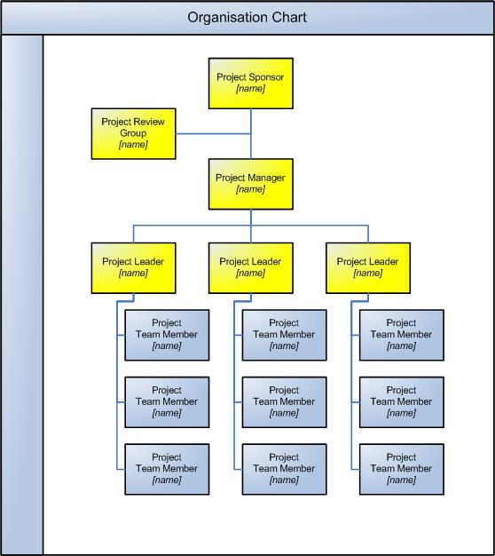

Project Plan

Approach
Describe the approach to be taken to implement each of the phases within the project.

Phase | Approach©
Initiation | Outline the method by which the project will be further defined, the project team appointed and the Project Office established.
Planning | Define the overall planning process to ensure that the phases, activities and tasks are undertaken in a co-ordinated fashion.
Execution | Describe the generic phases and activities required to build, test and implement the deliverables of the project.
Closure | Describe the steps required to release the deliverables to the business, close the project office, reallocate staff and perform a Post Implementation Review of the project.

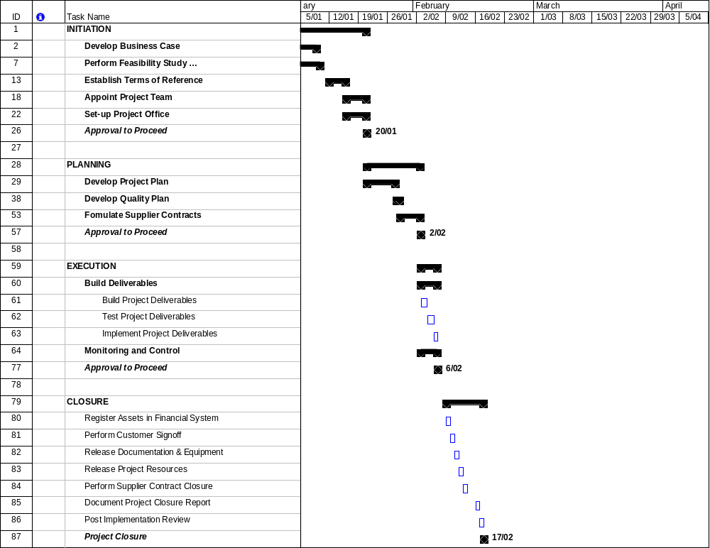
Overall Plan
Provide a summarized plan outlining the sequence of each of the phases listed above.

A more detailed Project Plan will be drawn up during the “Planning” phase of the project.

Milestones
List the major project milestones and the required delivery dates. A ‘milestone’ is a significant event or stage to be completed. Explain why each milestone is critical to the project, as follows:

Milestone | Date© | Description
Milestone Title | xx/yy/zz | Explain why milestone date is critical to business

Dependencies
List any project activities which:

- Will impact on another activity external to the project
- Will be impacted on by the non/delivery of another activity external to the project

Project Activity | Impacts on | Impacted on by | Criticality© | Date
Planned Activity | External Activity | External Activity | Low/Medium/High | xx/yy/zz

Resource Plan
Summarize the duration and effort required for each project team member, as follows:

Role | Start Date | End Date | % Effort
Project Role | xx/yy/zzzz | xx/yy/zzzz | xx/yy/zzzz

A detailed Resource Plan will be drawn up during the “Planning” phase of this project.

Financial Plan
Summarize the project budget approved (within the Business Case) as follows:

Category | Cost© | Value
People | - Salaries of project staff  - Contractors and outsourced parties  - Training courses | $ x  $ x  $ x
Physical | - Building premises for project team  - Equipment and materials  - Tools (computers, cabling, phones…) | $ x  $ x  $ x
Marketing | - Advertising / branding  - Promotional materials  - PR and communications | $ x  $ x  $ x
Organisational | - Operational downtime  - Short-term loss in productivity  - Cultural change | $ x  $ x  Describe

A detailed Financial Plan will be drawn up during the “Planning” phase of this project.

Quality Plan
Briefly describe the various processes to be undertaken to ensure the success of the project.

Process© | Description
Quality Management | Summary of how the process will be undertaken
Change Management
Risk Management
Issue Management
Configuration Management
Document Management
Acceptance Management
Procurement Management
Financial Management
Timesheet Management
Project Reporting
Project Communications

A detailed Quality Plan will be drawn up during the “Planning” phase of this project.

Project Considerations

Risks
Summarize the most apparent risks associated with the project. Risks are defined as “any event which may adversely affect the ability of the solution to produce the required deliverables”. Risks may be Strategic, Environmental, Financial, Operational, Technical, Industrial, Competitive or Customer related. Complete the following table:

Description | Likelihood | Impact© | Mitigating Actions
Inability to recruit skilled resource | Low | Very High | Outsource project to a company with proven industry experience and appropriately skilled staff
Technology solution is unable to deliver required results | Medium | High | Complete a pilot project to prove the full technology solution
Additional capital expenditure may be required in addition to that approved | Medium | Medium | Maintain strict capital expenditure processes during the project

To complete this section thoroughly, it may be necessary to undertake a formal Risk Assessment (by documenting a Risk Management Plan). To reduce the likelihood and impact of each risk's eventuating, clear ‘mitigating actions’ should be defined.

Issues
Summarize the highest priority issues associated with the project. Issues are defined as “any event which currently adversely affects the ability of the solution to produce the required deliverables”. Complete the following table:

Description© | Priority | Resolution Actions
Required capital expenditure funds have not been budgeted | High | Request funding approval as part of this proposal
Required computer software is only at ‘beta’ phase and has not yet been released live | Medium | Design solution based on current software version and adapt changes to solution once the final version of the software has been released
Council approval must be sought to implement the final solution | Low | Initiate the council approval process early so that it does not delay the final roll-out process.

Assumptions
List the major assumptions identified with the project to date. Examples include:

- There will be no legislative, business strategy or policy changes during this project
- Prices of raw materials will not increase during the course of the project
- Additional human resources will be available from the business to support the project. ©

Constraints
List the major constraints identified with the project to date. Examples include:

- The financial budget allocated is fixed and does not allow for over-spending
- There are limited technical resource available for the project
- The technical solution must be implemented after-hours to minimize the operational impact on the business.

Appendix

Supporting Documentation
Attach any documentation you believe is relevant to the Project Charter, including:

- Curricula Vitae (CVs) for key project staff
- Approved Business Case
- Approved Feasibility Study
- Research Materials
- External quotes or tenders
- Detailed financial planning spreadsheets
- Other relevant information or correspondence. ©

